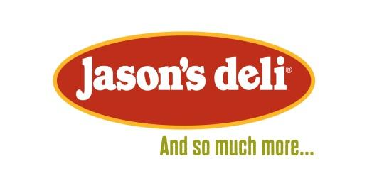
We’re taking orders!

Student Name__________________________________________

Please check the camp you are registered for:
( ) Week One - Draw & Illustrate ( ) Week 2 - 3D Character Forming ( ) Week Three - Pastels, Paints, Pallets, & Plein-Air

Lunch Choices (please check one):
( ) Macaroni & Cheese
( ) Cheese Pizza
( ) Pepperoni Pizza
( ) Chicken Nuggets w/Chips
( ) Chicken Alfredo
( ) Baked Potato w/ Cheese, Bacon, & Butter
( ) Peanut Butter & Jelly White w/Chips on White or Wheat (Circle Bread)
( ) Ham & Cheese Sandwich w/Chips on White or Wheat (Circle Bread)
( ) Turkey & Cheese Sandwich w/Chips on White or Wheat (Circle Bread)
( ) All Beef Hot Dog w/Chips (Ketchup & Mustard on side)
( ) Grilled Cheese Sandwich w/Chips on White or Wheat (Circle Bread)
( ) Gluten Free Chicken Nuggets w/Chips
( ) Bowtie Pasta w/Meatballs

Drink Choices (please check one):
( ) Organic Apple Juice
( ) White Milk
( ) Chocolate Milk
( ) Bottled Water

