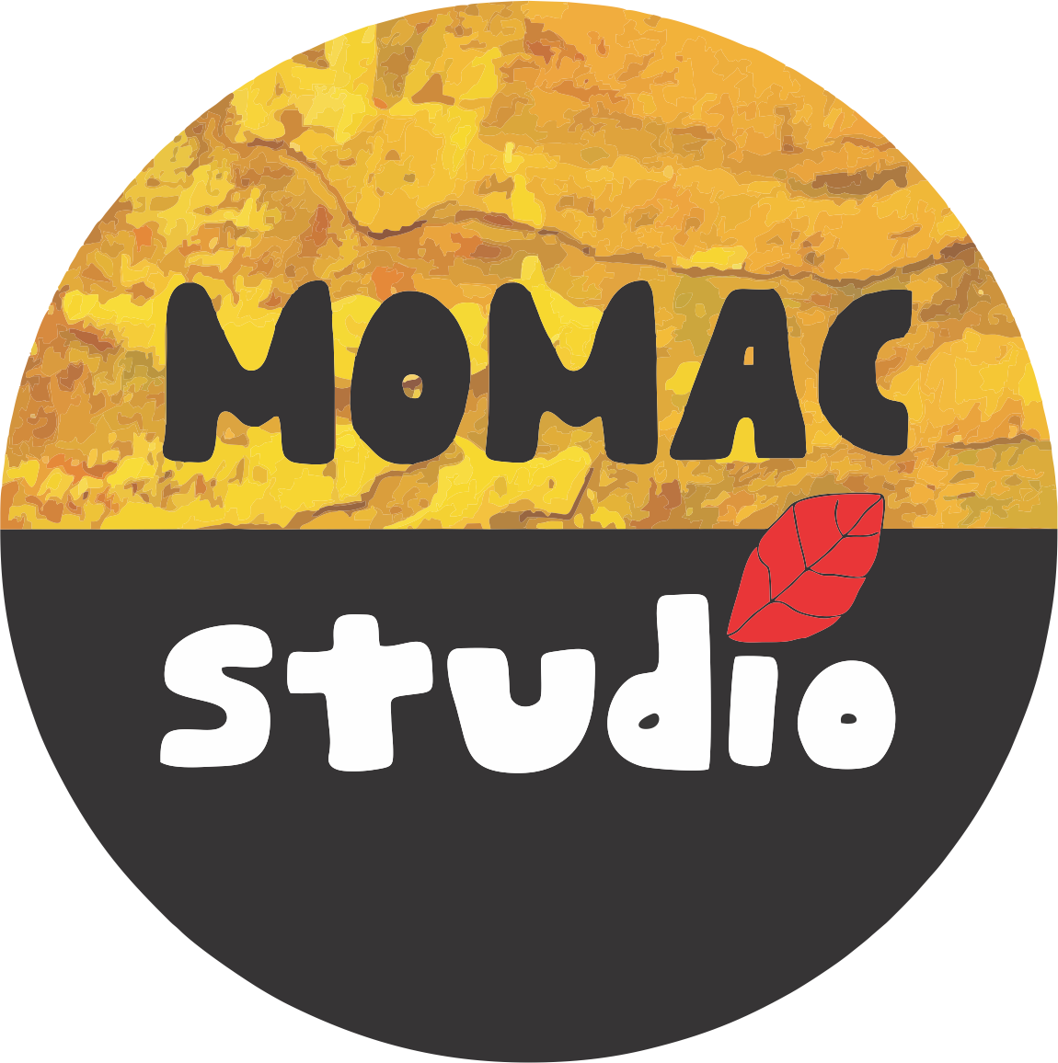*MOMAC Studio is offering lunch through Panera Bread this summer. All meals are an additional $8 and can be ordered by the day. Water and treats will be provided by MOMAC Studio.
Student Name________________________________________________________ Camp Week (circle one): 1 2 3
MONDAY | TUESDAY | WEDNESDAY | THURSDAY | FRIDAY
Please check one:  ( ) Signature Mac & Cheese Kids Meal  ( ) Kids Turkey Chili  ( ) Kids Chicken Noodle Soup  ( ) Kids Vegetarian Creamy Tomato Soup  ( ) Kids Ten Vegetable Soup  ( ) Kids Broccoli Cheddar Soup  ( ) Kids Bistro French Onion Soup  ( ) Kids Cream of Chicken & Wild Rice Soup  ( ) Kids Grilled Cheese  ( ) Kids Turkey Sandwich  ( ) Kids Smoked Ham Sandwich  ( ) Kids Bacon Tomato Grilled Cheese  ( ) Kids Napa Almond Chicken Sandwich  ( ) Kids Steak & Arugula Sandwich  ( ) Kids Tuna Salad Sandwich  ( ) Kids Roasted Turkey, Apple & Cheddar Sandwich  ( ) Kids BBQ Chicken Flatbread  ( ) Kids Greek Salad  ( ) Kids Chicken Caesar Salad  ( ) Kids Asian Sesame Chicken Salad  ( ) Kids Seasonal Greens Salad  ( ) Kids Green Goddess Chicken Cobb Salad  ( ) Kids Caesar Salad  ( ) Kids Fuji Apple Chicken Salad | Please check one:  ( ) Signature Mac & Cheese Kids Meal  ( ) Kids Turkey Chili  ( ) Kids Chicken Noodle Soup  ( ) Kids Vegetarian Creamy Tomato Soup  ( ) Kids Ten Vegetable Soup  ( ) Kids Broccoli Cheddar Soup  ( ) Kids Bistro French Onion Soup  ( ) Kids Cream of Chicken & Wild Rice Soup  ( ) Kids Grilled Cheese  ( ) Kids Turkey Sandwich  ( ) Kids Smoked Ham Sandwich  ( ) Kids Bacon Tomato Grilled Cheese  ( ) Kids Napa Almond Chicken Sandwich  ( ) Kids Steak & Arugula Sandwich  ( ) Kids Tuna Salad Sandwich  ( ) Kids Roasted Turkey, Apple & Cheddar Sandwich  ( ) Kids BBQ Chicken Flatbread  ( ) Kids Greek Salad  ( ) Kids Chicken Caesar Salad  ( ) Kids Asian Sesame Chicken Salad  ( ) Kids Seasonal Greens Salad  ( ) Kids Green Goddess Chicken Cobb Salad  ( ) Kids Caesar Salad  ( ) Kids Fuji Apple Chicken Salad | Please check one:  ( ) Signature Mac & Cheese Kids Meal  ( ) Kids Turkey Chili  ( ) Kids Chicken Noodle Soup  ( ) Kids Vegetarian Creamy Tomato Soup  ( ) Kids Ten Vegetable Soup  ( ) Kids Broccoli Cheddar Soup  ( ) Kids Bistro French Onion Soup  ( ) Kids Cream of Chicken & Wild Rice Soup  ( ) Kids Grilled Cheese  ( ) Kids Turkey Sandwich  ( ) Kids Smoked Ham Sandwich  ( ) Kids Bacon Tomato Grilled Cheese  ( ) Kids Napa Almond Chicken Sandwich  ( ) Kids Steak & Arugula Sandwich  ( ) Kids Tuna Salad Sandwich  ( ) Kids Roasted Turkey, Apple & Cheddar Sandwich  ( ) Kids BBQ Chicken Flatbread  ( ) Kids Greek Salad  ( ) Kids Chicken Caesar Salad  ( ) Kids Asian Sesame Chicken Salad  ( ) Kids Seasonal Greens Salad  ( ) Kids Green Goddess Chicken Cobb Salad  ( ) Kids Caesar Salad  ( ) Kids Fuji Apple Chicken Salad | Please check one:  ( ) Signature Mac & Cheese Kids Meal  ( ) Kids Turkey Chili  ( ) Kids Chicken Noodle Soup  ( ) Kids Vegetarian Creamy Tomato Soup  ( ) Kids Ten Vegetable Soup  ( ) Kids Broccoli Cheddar Soup  ( ) Kids Bistro French Onion Soup  ( ) Kids Cream of Chicken & Wild Rice Soup  ( ) Kids Grilled Cheese  ( ) Kids Turkey Sandwich  ( ) Kids Smoked Ham Sandwich  ( ) Kids Bacon Tomato Grilled Cheese  ( ) Kids Napa Almond Chicken Sandwich  ( ) Kids Steak & Arugula Sandwich  ( ) Kids Tuna Salad Sandwich  ( ) Kids Roasted Turkey, Apple & Cheddar Sandwich  ( ) Kids BBQ Chicken Flatbread  ( ) Kids Greek Salad  ( ) Kids Chicken Caesar Salad  ( ) Kids Asian Sesame Chicken Salad  ( ) Kids Seasonal Greens Salad  ( ) Kids Green Goddess Chicken Cobb Salad  ( ) Kids Caesar Salad  ( ) Kids Fuji Apple Chicken Salad | Please check one:  ( ) Signature Mac & Cheese Kids Meal  ( ) Kids Turkey Chili  ( ) Kids Chicken Noodle Soup  ( ) Kids Vegetarian Creamy Tomato Soup  ( ) Kids Ten Vegetable Soup  ( ) Kids Broccoli Cheddar Soup  ( ) Kids Bistro French Onion Soup  ( ) Kids Cream of Chicken & Wild Rice Soup  ( ) Kids Grilled Cheese  ( ) Kids Turkey Sandwich  ( ) Kids Smoked Ham Sandwich  ( ) Kids Bacon Tomato Grilled Cheese  ( ) Kids Napa Almond Chicken Sandwich  ( ) Kids Steak & Arugula Sandwich  ( ) Kids Tuna Salad Sandwich  ( ) Kids Roasted Turkey, Apple & Cheddar Sandwich  ( ) Kids BBQ Chicken Flatbread  ( ) Kids Greek Salad  ( ) Kids Chicken Caesar Salad  ( ) Kids Asian Sesame Chicken Salad  ( ) Kids Seasonal Greens Salad  ( ) Kids Green Goddess Chicken Cobb Salad  ( ) Kids Caesar Salad  ( ) Kids Fuji Apple Chicken Salad
Please check one:  ( ) Chips  ( ) Yogurt  ( ) French Baguette  ( ) Apple | Please check one:  ( ) Chips  ( ) Yogurt  ( ) French Baguette  ( ) Apple | Please check one:  ( ) Chips  ( ) Yogurt  ( ) French Baguette  ( ) Apple | Please check one:  ( ) Chips  ( ) Yogurt  ( ) French Baguette  ( ) Apple | Please check one:  ( ) Chips  ( ) Yogurt  ( ) French Baguette  ( ) Apple

